

oneM2M
Technical Report
Document Number | oneM2M-TR-0003-Architecture_Analysis_Part_2-V-0.5.0
Document Name: | Architecture Analysis - Part 2:  Study for the merging of architectures proposed for consideration by oneM2M
Date: | 2013-Jul-28
Abstract: | Technical analysis for the merging of existing M2M-related Architecture work undertaken by the oneM2M Type 1 Partners

This Specification is provided for future development work within oneM2M only. The Partners accept no liability for any use of this Specification.
The present document has not been subject to any approval process by the oneM2M Partners Type 1. Published oneM2M specifications and reports for implementation should be obtained via the oneM2M Partners' Publications Offices.

About oneM2M
The purpose and goal of oneM2M is to develop technical specifications which address the need for a common M2M Service Layer that can be readily embedded within various hardware and software, and relied upon to connect the myriad of devices in the field with M2M application servers worldwide.
More information about oneM2M may be found at: http//www.oneM2M.org
Copyright Notification
No part of this document may be reproduced, in an electronic retrieval system or otherwise, except as authorized by written permission.
The copyright and the foregoing restriction extend to reproduction in all media.
© 2013, oneM2M Partners Type 1 (ARIB, ATIS, CCSA, ETSI, TIA, TTA, TTC).
All rights reserved.
Notice of Disclaimer & Limitation of Liability
The information provided in this document is directed solely to professionals who have the appropriate degree of experience to understand and interpret its contents in accordance with generally accepted engineering or other professional standards and applicable regulations. No recommendation as to products or vendors is made or should be implied.
NO REPRESENTATION OR WARRANTY IS MADE THAT THE INFORMATION IS TECHNICALLY ACCURATE OR SUFFICIENT OR CONFORMS TO ANY STATUTE, GOVERNMENTAL RULE OR REGULATION, AND FURTHER, NO REPRESENTATION OR WARRANTY IS MADE OF MERCHANTABILITY OR FITNESS FOR ANY PARTICULAR PURPOSE OR AGAINST INFRINGEMENT OF INTELLECTUAL PROPERTY RIGHTS. NO oneM2M PARTNER TYPE 1 SHALL BE LIABLE, BEYOND THE AMOUNT OF ANY SUM RECEIVED IN PAYMENT BY THAT PARTNER FOR THIS DOCUMENT, WITH RESPECT TO ANY CLAIM, AND IN NO EVENT SHALL oneM2M BE LIABLE FOR LOST PROFITS OR OTHER INCIDENTAL OR CONSEQUENTIAL DAMAGES. oneM2M EXPRESSLY ADVISES ANY AND ALL USE OF OR RELIANCE UPON THIS INFORMATION PROVIDED IN THIS DOCUMENT IS AT THE RISK OF THE USER.

Contents
1 Scope 3
2 References 3
2.1 Normative References 3
2.2 Informative References 3
3 Definitions abbreviations and acronyms 4
3.1 Definitions 4
3.2 Abbreviations 4
3.3 Acronyms 4
4 Conventions 4
5 Analysis of Functional Entities 5
5.1 Existing Functional Entities: ATIS, ETSI, TIA 5
6 Analysis of existing Reference Points 6
6.1 Reference Point analysis 6
6.2 Reference Point vs Functions 9
7 Analysis of architecture styles 9
7.1 REST 9
7.2 SOAP 10
8 Conclusions 10
History 11

1 Scope
The present document provides an evaluation of existing M2M-related Architecture work undertaken by the founding partners of oneM2M, including: the Association of Radio Industries and Businesses (ARIB) and the Telecommunication Technology Committee (TTC) of Japan; the Alliance for Telecommunications Industry Solutions (ATIS) and the Telecommunications Industry Association (TIA) of the USA; the China Communications Standards Association (CCSA); the European Telecommunications Standards Institute (ETSI); and the Telecommunications Technology Association (TTA) of Korea. Common Functional Entities and Reference Points are identified, as well as critical differences. New functionality will not be considered as part of this study.
The present document is intended to ensure a common understanding of existing M2M Architectural approaches, in order to facilitate future normative work resulting in oneM2M Technical Specifications.
The present document has been prepared under the auspices of the oneM2M Technical Plenary, by the oneM2M Architecture Working Group.

2 References
References are either specific (identified by date of publication and/or edition number or version number) or non-specific. For specific references, only the cited version applies. For non-specific references, the latest version of the referenced document (including any amendments) applies.

2.1 Normative References
The following referenced documents are necessary for the application of the present document.
Not applicable.

2.2 Informative References
The following referenced documents from non-Partners of oneM2M provide additional information for the analysis provided within the present document.
[i.1] oneM2M Drafting Rules.
[i.2] oneM2M TR-0002: "Architecture Analysis Part 1".
[i.3] 3GPP2 X.P0068: "Network Enhancements for Machine to Machine) that relate to the architectural enhancements and deployment models for supporting Machine to Machine services in 3GPP2 networks".
[i.4] ATIS Machine to Machine (M2M) Committee
[i.5] ETSI Machine to Machine (M2M) Committee
[i.6] IETF draft-ietf-core-coap: "Constrained Application Protocol (CoAP)".
[i.7] OMA Lightweight M2M
[i.8] OMA-DM (OMA): "OMA Device Management".
[i.9] Fielding, R.T., (2000), Dissertation: "Architectural Styles and the Design of Network-based Software Architectures, Chapter 5 - Representational State Transfer (REST)". University of California Irvine
[i.10] TIA TR-50 - M2M: "Smart Device Communications".

3 Definitions Abbreviations and Acronyms

3.1 Definitions
For the present document, the following terms and definitions apply:
-none-

3.2 Abbreviations
For the present document, the following abbreviations apply:
-none-

3.3 Acronyms
For the present document, the following acronyms apply:
3GPP 3rd Generation Partnership Project
AAA Authentication, Authorization and Accounting
API Application programming Interface
ARIB Association of Radio Industries and Businesses (JP)
ASP Application Service provider
ATIS Alliance for Telecommunications Industry Solutions
CCSA China Communications Standards Association
CoAP Constrained Application Protocol
CoRE Constrained Restful Environments
DA Device Application
DSCL Device Service Capability Layer
ETSI European Telecommunications Standards Institute
GA Gateway Applications
GSCL Gateway Service Capability Layer
HATEOAS Hypermedia As The Engine Of Application State
HTTP HyperText Transfer Protocol
IETF Internet Engineering Task Force
IF Interface
M2M Machine to Machine (communications)
MAS M2M Authentication Server
MSBF M2M Service Bootstrap Function
MSP Machine to Machine Service Provider
MTC Machine Type Communication
NA Network Applications
NSCL Network Service Capability Layer
NW Network
OMA LWM2M Open Mobile Alliance - Light Weight M2M
OMA Open Mobile Alliance
PoA Point of Attachment
REST Representational State Transfer is a style of API interface
RPC Remote Procedure Call
SOAP Simple Object Access Protocol
TIA Telecommunications Industry Association
TTA Telecommunications Technology Association
TTC Telecommunication Technology Committee
WSDL Web Service Description Language
XML Extensible Markup Language

4 Conventions
The key words "Shall", "Shall not", "May", "Need not", "Should", "Should not" in the present document are to be interpreted as described in the oneM2M Drafting Rules [i.1].

5 Analysis of Functional Entities

5.1 Existing Functional Entities: ATIS, ETSI, TIA
This clause provides a comparative analysis of existing ATIS M2M [i.4], ETSI M2M [i.5], and TIA TR-50 [i.10], functional architectural entities.
Table 5.1 provides a comparative matrix of the functional architectural entities supported by each architecture.
Table 5.1: TIA, ATIS, and ETSI M2M Functional Entity Comparative Matrix
Functional Entity | TIA TR-50 | ATIS | ETSI M2M
M2M Service Capability hosted in the network domain | Yes  Server Container | Yes  Service Capabilities | Yes  Network Service Capability Layer (NSCL)
M2M Service Capability hosted on an intermediary node | Yes  PoA Container | No | Yes  Gateway Service Capability Layer (GSCL)
M2M Service Capability hosted on an M2M Device | Yes  PoA Container | No | Yes  Device Service Capability Layer (DSCL)
Applications in the network domain | Yes  home applications | Yes  Applications | Yes  Network Applications (NA)
Applications in the intermediary node | Yes  Node Application | No | Yes  Gateway Application (GA)
Applications in the M2M Device | Yes  PoA Application | No | Yes  Device Application (DA)
M2M Network | Yes  Server | Yes  Network Service Functions | Yes  Network Domain
M2M intermediary node | Yes  PoA Device | No | Yes  M2M Gateway
M2M Device | Yes  PoA Device | Yes  Device | Yes  Device with Service Capabilities (D)  Device without Service Capabilities (D')  Legacy non-ETSI Device (d)
AAA Server | Yes  AAA-SD | No | Yes  M2M Authentication Server (MAS), M2M Service Bootstrap function (MSBF)

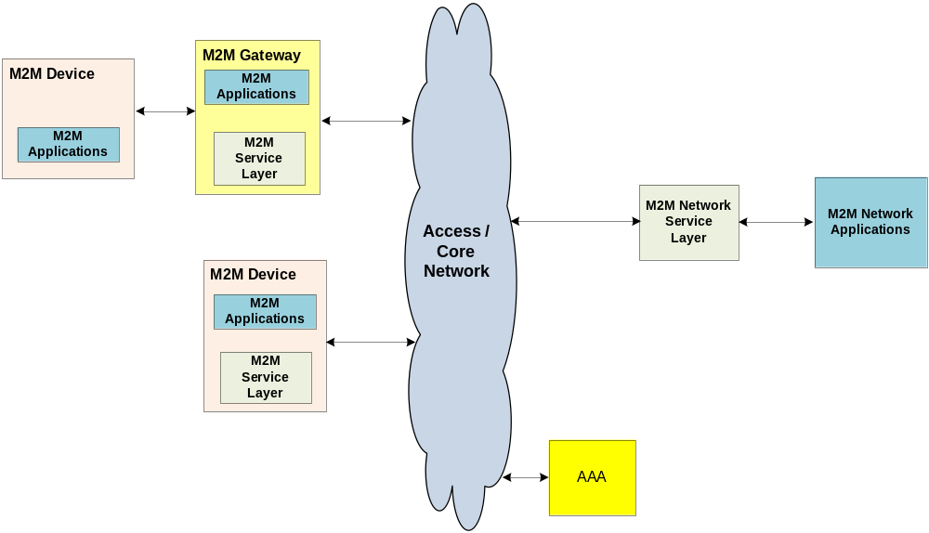
NOTE: Functional Elements depicted in this figure may be placed anywhere, not necessarily outside the Access/Core network. The role/placement of AAA Server is for further study.

Figure 5.1: TIA, ATIS, and ETSI M2M Functional Architectural Entities
Figure 5.1 provides a high level overview of the common components when examining TIA TR-50 [i.10], ETSI M2M [i.5], and ATIS M2M [i.4] functional architectural entities.

6 Analysis of existing Reference Points

6.1 Reference Point analysis
This clause provides a comparative analysis of existing TIA TR-50 [i.10], ETSI M2M [i.5], and ATIS M2M [i.4], architectural reference points. Figure 6.1 shows the reference points from each source consolidated into a single functional architecture. Table 6.1 provides a comparative matrix of the reference points supported by each architecture.
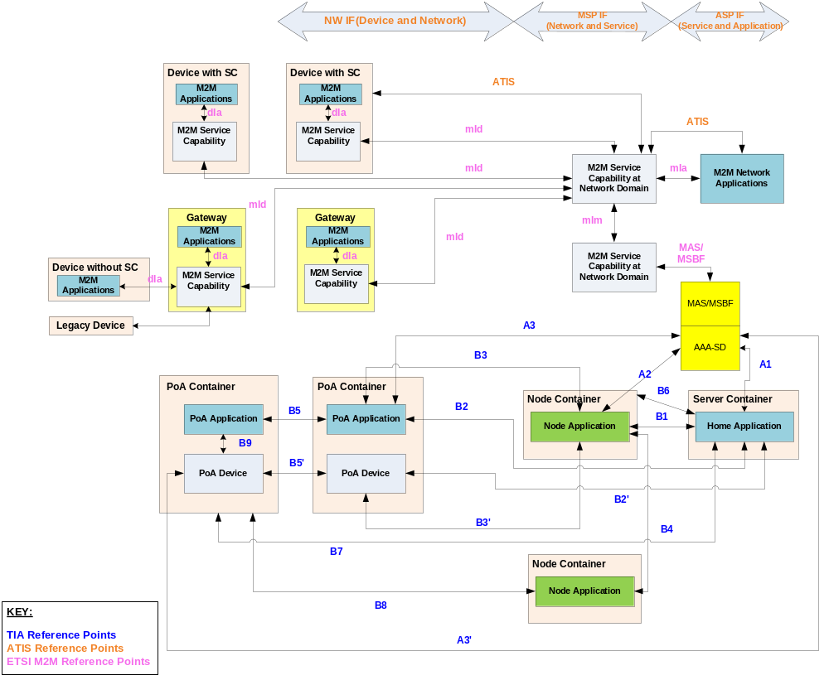
Figure 6.1: TIA, ATIS, and ETSI M2M Reference Point Analysis
Figure 6.1 provides a high level architectural overview with reference points of the common components when examining TIA TR-50, ETSI M2M, and ATIS M2M functional architectural entities.
Details of the reference points are provided in tables 6.1 and 6.2. Table 6.1 also provides details of 3GPP reference points pertaining to Machine Type Communication (MTC).
Table 6.1: TIA, ETSI, ATIS, and 3GPP Reference Point Analysis for M2M
Reference Point/Interface Description | Corresponding Reference Point |  |  |  | Comment
Reference Point/Interface Description | TIA | ETSI | ATIS | 3GPP | Comment
M2M Device Application ↔  M2M Device Application | B5
M2M Gateway Application ↔  M2M Gateway Application | B4
M2M Device Application ↔  M2M Gateway Application | B3
M2M Device Application ↔  M2M Network Application | B2
M2M Gateway Application ↔  M2M Network Application | B1
M2M Device Application ↔  M2M Device | B9
M2M Gateway Application ↔  M2M Device | B3'
M2M Network Application ↔  M2M Device | B2' |  | * |  | * ATIS Shows an interface 'Traffic Flow (Option 2)'
M2M Network Application ↔  Access/Core Network Provider |  |  |  | Gi/Sgi
M2M Device Application ↔  M2M Device Service Layer |  | dIa
M2M Device Application ↔  M2M Gateway Service Layer |  | dIa
M2M Gateway Application ↔  M2M Device Service Layer | B8
M2M Gateway Application ↔  M2M Gateway Service Layer |  | dIa
M2M Network Application ↔  M2M Device Service Layer | B7
M2M Network Application ↔  M2M Gateway Service Layer | B6
M2M Network Application ↔  M2M Network Service Layer |  | mIa | ASP IF
M2M Device Service Layer ↔  M2M Network Service Layer |  | mId
M2M Gateway Service Layer ↔  M2M Network Service Layer |  | mId
M2M Network Service Layer ↔  M2M Network Service Layer |  | mIm
M2M Network Service Layer ↔  M2M Device |  |  | * |  | * ATIS Shows an interfaces 'Traffic Flow (Option 1)' and 'Device Mangement'
M2M Network Service Layer ↔ Access/Core Network Provider |  |  | MSP IF | T_{SP}
M2M Device ↔ M2M Device | B5'
M2M Device ↔  Access/Core Network Provider |  |  | NW IF
M2M Network Application ↔  AAA Server | A1
M2M Gateway Application ↔  AAA Server | A2
M2M Device Application ↔  AAA Server | A3
M2M Device ↔  AAA Server | A3'
M2M Network Service Layer ↔  AAA Server |  | MAS/  MSBF

6.2 Reference Points vs. Functions
Table 6.2 provides a comparative analysis of the reference points defined by TIA TR-50 [i.10], ATIS M2M [i.4], and ETSI M2M [i.5].
Table 6.2: TIA, ATIS, and ETSI M2M Comparative Reference Point Feature Matrix
Feature | TIA TR-50 | ATIS M2M | ETSI M2M
Reference points to support M2M Service Capabilities hosted on a M2M device | Yes  (B7, B8) | No | Yes  (dIa,mId)
Reference points to support an intermediary M2M gateway/node | Yes  (B1,B4,B6,B3,B3',B8, A2) | No | Yes  (dIa,mId)
Reference points to support communication with access/core network entities | No | Yes  (NW IF, MSP IF) | No
Reference points to support M2M Service Capabilities hosted in the network | No | Yes  (MSP IF, ASP IF) | Yes  (mIa,mId,mIm)
Reference points to support hierarchical M2M Service Capabilities on Device, Gateway and Network | No | No | Yes  (mIa,mId,dIa)
Reference points to support direct application-to-application communication | Yes  (B1, B2, B3, B4, B5) | No | No
Reference points to support direct device-to-device communication | Yes  (B5') | No | No
Reference points to support communication between two instances of M2M Service Capabilities hosted in the network | No | No | Yes  (mIm)
Reference points to support direct communication between network applications and devices and gateways (i.e. bypass M2M Network Service Capabilities) | Yes  (B2') | Yes  (Optional Traffic Flow option #2) | No
Reference points to support direct communication between network applications and M2M Service Capabilities hosted on devices and gateways (i.e. bypass M2M Network Service Capabilities) | Yes  (B6, B7) | No | No

7 Analysis of architecture styles

7.1 REST
REST stands for Representational State Transfer. It is a style of API interface. When the API of a system qualifies REST's features, we say the system is RESTful.
REST was first described by R.T. Fielding in his Doctoral Dissertation [i.9]. The basic notion of REST is resource. Any information in the oneM2M system that can be named and addressed can be a resource: a document or image, a temporal service, a collection of other resources, a non-virtual object, a fragment of data, and so on. REST can be summarised to several basic constraints.
- Client to Server. Client is separated from the Server by interfaces. As long as the interface stays the same, Client and Server can evolve separately.
- The interface between client and server is Stateless. The request on the interface contains all the information needed for the server to handle the request.
- Cache. Cache is used to improve the scalability and performance.
- Uniform Interface. The resources could be addressed by the same methods. There are four constraints about the Uniform Interface:
- identification of resources;
- manipulation of resources through representations;
- self-descriptive messages;
- hypermedia as the engine of application state (HATEOAS).
- Layered system. The system is divided by several layers. Each layer provides functions to the upper layer by utilise the functions provided by the lower layer. Each layer can evolve separately.
RESTful guarantees that the client needs no prior knowledge of the server. Every client can access to the resources using uniform interfaces. The method to parse the resource is along with the resource. A REST Client can interact with the server entirely using hypermedia provided by the server, which is the concept of HATEOAS. Resources are connected with each other using links. The REST Client can navigate from resources to resources to obtain the information desired. The HATEOAS constraint serves to decouple client and server in a way that allows the server to evolve functionality independently.
More and more architecture designers have adopted RESTful architecture in the M2M area; ETSI M2M [i.5], OMA DM2.0 [i.8], OMA LWM2M [i.7], IETF CoRE CoAP [i.6], etc.

7.2 SOAP
Web services provide a layer of abstraction above existing software, such as application servers, messaging, and packaged applications.
Applications expose interfaces that are described in a machine process-able format, the Web Service Description Language (WSDL). It is also possible for applications to interact through SOAP interfaces which provide a means to describe message format. These messages are often transported over HTTP and encoded using XML.
SOAP is method for exchanging XML based message over the Internet for providing and consuming web services. SOAP message are transferred forming the SOAP-Envelope.
RPC (remote procedure call) is another way of providing and consuming web services. It uses XML to encode and decode the remote procedure call along with its parameters.

8 Conclusions
The present document offers an overview and summary of the most current standards activity related to M2M, with a goal of providing a common understanding of existing M2M Architectural approaches.
The present document may be used to facilitate future normative work resulting in oneM2M Technical Specifications.

History
Publication history
V.1.0.0 | <dd Mmm 2013> | <Milestone: Scheduled for TP#3 – tbc>

Draft history (to be removed on publication)
V.0.0.1 | 07 Feb 2013 | Rapporteur Input – Skeleton Draft
V0.0.2 | 13 Feb 2013 | Rapporteur Input – Skeleton Draft (editorial revisions)
V0.0.3 | 25 Feb 2013 | Rapporteur Input – Skeleton Draft (input to ARC F2F meeting)
V0.0.4 | 27 Feb 2013 | Rapporteur Input – Skeleton Draft (agreed during ARC F2F meeting)
V0.0.5 | 28 Feb 2013 | Rapporteur Input – Skeleton Draft (revised document title)
V0.1.0 | 11 Mar 2013 | Rapporteur Output Draft from TP#003 including following agreed documents:  oneM2M-ARC-2012-0168R03 (Initial text for clause 5 and clause 6)
V0.1.1 | 18-Mar-2013 | Rapporteur Output Draft from ARC call 14-Mar-2013, with following revisions:  1) Added Table 6.1 and Table 6.2 from agreed document 0168R03 (these tables were inadvertently omitted from V0.1.0)  2) Added Note above Figure 5.1 re: placement of Functional Elements and AAA  3) Changed label on "M2M Constrained Device" in Figure 5.1 to "M2M Device"
V0.2.0 | 17-Apr-2013 | Rapporteur Output Draft from TP#004 including following agreed documents:  oneM2M-ARC-2013-0250 (Introduction of REST)
V0.3.0 | 09-June-2013 | Rapporteur Input Draft for TP#005 based on output draft V0.2.0 from TP#004: Updated clauses 2.1, 5.1, 6.1, 6.2, & 8. Removed clauses 6.3, 8.1 through 8.5, and Annex
V0.3.1 | 18-June-2013 | Replaced clause 7.2 title from Web Service to SOAP. Removed editor notes related to further input from TIA.
V0.4.0 | 25 June-2013 | Pre-approval processing by the Secretariat
V0.4.0a | July 2013 | Clean-up done by editHelp!  e-mail: mailto:edithelp@etsi.org
V0.5.0 | 28 July 2013 | Editorial Changes and editHelp suggestions  Final version for TP Approval

